Fields of Fuel
Sample Student Worksheet
Game Goal:_________________________

Planting Year | Rank | Crop/Management Choices |  |  |  | Predict what will happen to your sustainability graph | Explain the reasoning behind your choices | Describe what actually happened to your sustainability graph | Explain: What caused the changes in your graph? Use other data from the game to support your answer.
 |  | Field 1 | Field 2 | Field 3 | Field 4
1
2
3
4
5
6
7
8
9
10

Notes to yourself:
Fields of Fuel
Sample In-Class Discussion Questions

Note: We recommend students play in pairs sharing a farm. Pairing promotes discussion and deliberation. Questions can be asked as discussed using the “think, pair share” approach.

Questions to ask before starting game play:
- Which of the dimensions of sustainability (economics, energy, environment) is most important? Why? Optional: After discussing as a class, have students vote for most important aspect and use results to adjust how each dimension is weighted in game.
- What is your initial plan for having the most sustainable farm? What is your reasoning behind this plan?
- What information are you using to make your plan?
- How will you assess the success (or failure) of your plan?
- Which dimension of sustainability will be the easiest to achieve?

Questions to ask during game play:
- What did you plant? Why did you plant it?
- Optional: What fertilizer level did you choose? Why?
- Optional: What tillage option did you choose? Why?
- Has anything surprising happened to your field?
- What do you notice about your score compared to other groups?
- What evidence are you using to make claims about what is more or less sustainable?
- Who is changing what they are planting and/or management decisions and who is keeping things the same? And why? What information are you using to make those decisions?
- What do you think is happening to produce the trends you are seeing in your graphs? Can you explain any dips or peaks?
- How would you change your strategy to make it more sustainable? Is this enough information to help you decide? How do you evaluate if this is a long-term sustainable management decision?

Questions to ask after game play:
- To the winning (or losing) group: What was your strategy? Did you change your strategy at all during the game? Why did that strategy work (not work)? What information did you use to decide how well you were doing?
- If we had played the game for more (or less) time, who would have won? Why? Does it matter how long we play?
- Does it matter what other players in the game are doing? If so how?
Choose a year in your graph where there is a big dip or jump. Explain what happened in that year? Did you make a change or did it have something to do with what other people were doing? How do you know?

Fields of Fuel
Sample Assessment Items
Organized by Learning Objective

Learning Objective 1: Describe the key dimensions of sustainability within the context of bioenergy crop production.
Potential Assessment Scenario and Questions:
Imagine you are asked to speak to a group of farmers about sustainable bioenergy crop production. How would you introduce each of the three dimensions of sustainability to them? For each dimension describe:
- What “makes up” that dimension?
- How can you maximize that dimension and not any of the others?
- Why is that dimension useful or important for the community to consider when thinking about sustainability?
- Rank the importance of that dimension compared to the other dimensions. Explain.

Learning Objective 2: Identify ecological and economic factors that affect agricultural systems.
Potential Assessment Scenario and Questions:
Suppose you are a new farmer just learning about sustainable farming practices. You have decided to try to maximize each dimension of sustainability on its own before trying to maximize them all together.
- What features of the system do you need to watch out for when considering environmental sustainability? Economic sustainability?
- How will you know when you have been successful at maximizing environmental sustainability? Economic sustainability? What data would you need to collect?
- Which dimension of sustainability will be the most challenging to maximize? Why?
- Is it possible to maximize both your economic and environmental sustainability at the same time? Why or why not?

Learning Objective 3: Use graphs to make sense of long- and short-term trends in data.

Potential Assessment Scenario and Questions (Basic):
A student like you has played the game for three years. For the first two years, she planted switchgrass on all of her fields. In the 3rd year, she planted corn in all fields. Below is a screenshot of her yield graph.

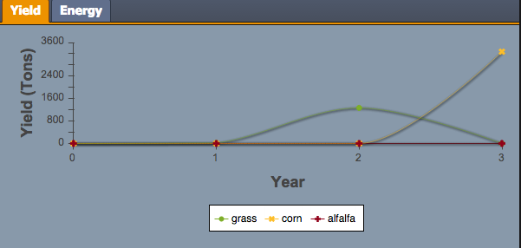

- How did her switchgrass yield change between years one and two? Why?
- Which crop, corn or switchgrass, would you expect to produce greater yields? Why?

After 11 years, you see the following graph, which compares her farms greenhouse gas emissions compared to the average for other farmers.

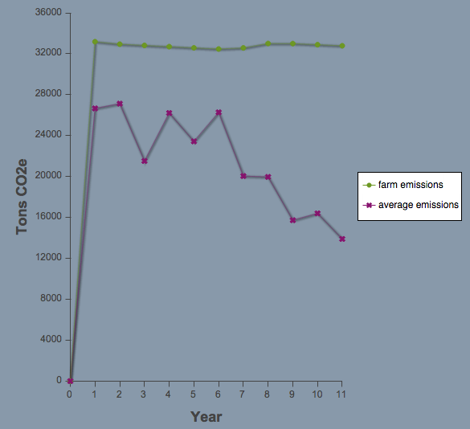

Answer these questions to help her make sense of the trends.
- Overall, how does her farms emissions compare to other farms?
- Over the course of the game is her farm doing better or worse compared to other farms for emissions? Explain why.

Potential Assessment Scenario and Questions (Advanced):
Imagine there is a student like you who is going to play the game in her class. For the first five years the student plants corn, she then decides to change to planting switchgrass.
- What would the graph of her economic score look like over the first 7 years of the game?
- What would the graph of her environmental score look like over the first 7 years of the game?
- What would the graph of her overall sustainability look like over the first 7 years of the game?
Did you need to make any assumptions about what other players are doing in order to draw these graphs? Why or why not?

Learning Objective 4: Explain the relationship between individual farmer management decisions and local ecological and economic outcomes.

Potential Assessment Scenario and Questions (Basic):
Farmer John plants corn in his fields for 10 years and Farmer Jane plants switchgrass in her fields for those same 10 years. At the end of that time,
- Which farm do you think will have the most money? Why?
- Which farm will have better soil health? Why?
- Which farm will have the better water quality? Why
- If you were to compete with these farmers to be the most sustainable, what strategy would you follow, John, Janes, something different? Explain.

Potential Assessment Scenario and Questions (Advanced):
A common strategy many students use in playing the game is “crop rotation.” Imagine a student uses that strategy by planting corn on two fields and cover crop (alfalfa) on the other two fields. The student then rotates which crops are on which field every other year. So the fields that had corn in years 1 and 2 would have switch grass in years 3 and 4, and vice versa.
- Draw a picture of what crops are planted on the students’ fields for the first 8 years of the game. You will create 8 pictures each with four fields.
- For each year and each field, use a plus to show whether the ecological score for that field goes up and a minus to show that the ecological score for that field goes down.
- Do the same drawing of pluses and minuses in a different color for the environmental score.
Use your trends of pluses and minuses to decide whether this crop rotation strategy is good or bad for this one farmer.

Learning Objective 5: Explain the relationship between individual farmer management decisions and global ecological and economic outcomes.

Potential Assessment Scenario and Questions:
Imagine you are a lawmaker for a small farming town in the Midwest. You have one farmer in the town that refuses to plant anything but corn. How will that affect:
- His own environmental impact?
- His own economic impact?
- His neighboring farm’s environmental impact?
- His neighboring farm’s economic impact?
- The overall group’s environmental impact?
- The overall group’s economic impact?
Use your answers to questions (1)-(6) to make an argument to the farmer for how his choice positively and negatively affects the community.

